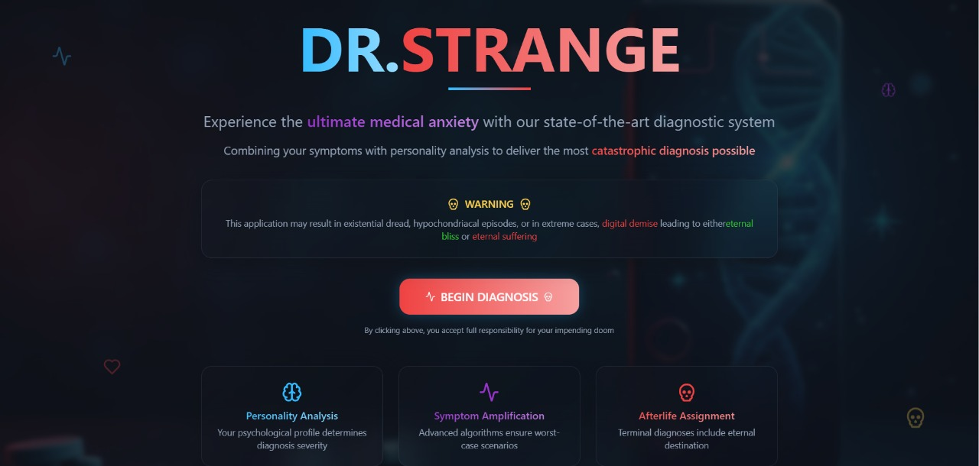

**DR.Strange🎯**

**https://doom-scroll-diagnostics.vercel.app/**

**Basic Details**

**Team Name: 200ok**

**Team Members**

* Member 1 ELIZABETH MARIAM MATHEW-SOE
* Member 2: GAYATHRI KUPPAM-SOE

**Project Description**

DR.strangediagnoses you with the worst possible disease for whatever symptoms you may be experiencing. To make the experience even more dramatic, it features a personality test: the worse your personality, the grimmer your diagnosis. Sometimes, you’re “diagnosed” straight to (virtual) heaven or hell!

**The Problem (that doesn't exist)**

Are people feeling far too comfortable with reasonable health apps and thoughtful diagnoses? The world needs a way to instantly assume the worst about every minor symptom…and judge their personality at the same time.

**The Solution (that nobody asked for)**

WithDR.Strange, enter your symptoms and complete a personality test, then watch as the app—powered by generative AI—diagnoses you with the most absurd, cataclysmic illness possible. If your personality test goes badly, things only get more catastrophic, sometimes leading to a fate worse than (virtual) death.

**Technical Details**

**Technologies/Components Used**

For Software:

* Languages: TypeScript
* Frameworks: React
* APIs: Gemini API (for generating AI-based predictions)
* Tools: Git, GitHub

For Hardware:

* No hardware required; runs entirely in the browser

**Implementation**

**Installation**

bash

git clone https://github.com/ELIZABETHMM36/doom-scroll-diagnostics.git

cd doom-scroll-diagnostics

npm install

**Run**

bash

npm start

**Project Documentation**

**Screenshots (Add at least 3)**

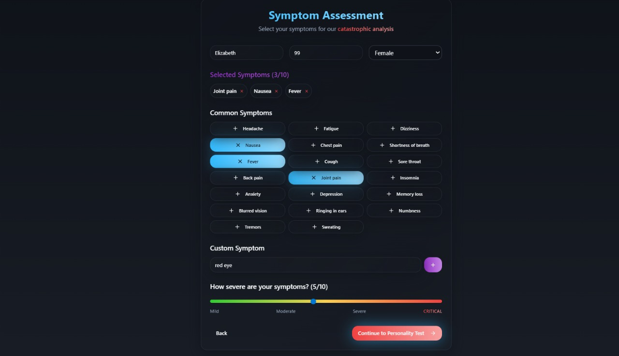  
Landing page where user enters symptoms and starts the personality test.

![Screenshot2]

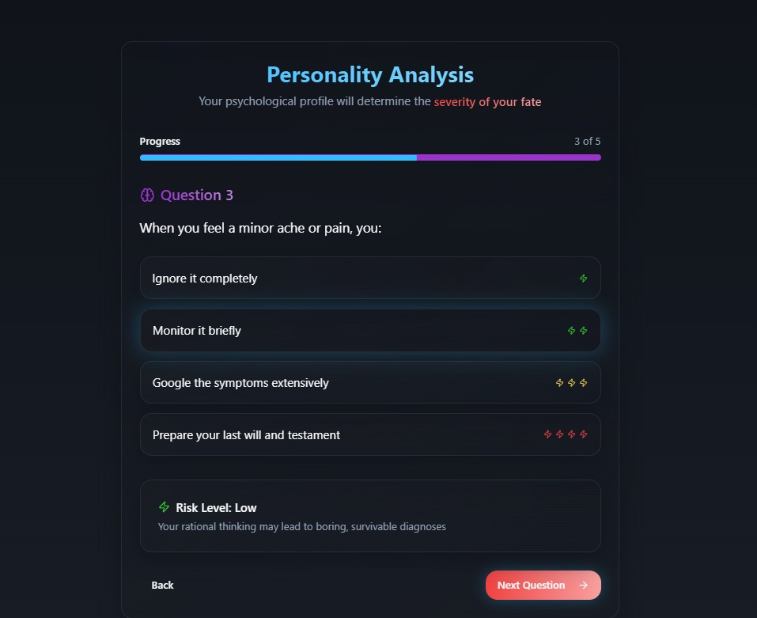  
Diagnosis screen displaying the most dramatic result generated by the Gemini API.

![Screenshot3]

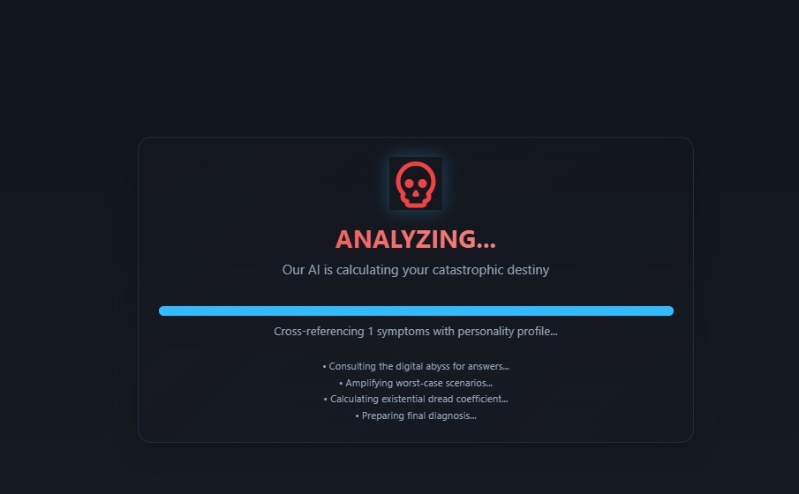  
Outcome page, revealing your (un)fortunate fate—heaven, hell, or something in between.

**Diagrams**

![Workflow](Add your workflow/architecture diagram here)  
This diagram shows the flow from user input to Gemini-powered diagnosis and final fate logic.

**Project Demo**

**Video**

https://go.screenpal.com/watch/cTjQlcnIWya  
Demo shows entering symptoms, getting a dramatic AI diagnosis, and navigating to the final result.

**Team Contributions**

* ELIZABETH : Built core React logic, integrated Gemini API for diagnosis predictions
* GAYATHRI: Designed personality test, implemented TypeScript types and state management
* TEAM: Handled project documentation, managed testing, crafted dramatic UI effects

Made with ❤ at TinkerHub Useless Projects